Fundamentals of Machine Learning

InnoStay – Stay Price Predictor

A PROJECT REPORT

Submitted by
Neha K (230701209)
Pavithra N (230701225)
Navitha M (230701208)


October, 2026

BONAFIDE CERTIFICATE

Certified that this project report “……….INNOSTAY……………..” is the bonafide work of “ ……NEHA K……PAVITHRA N……..NAVITHA M…..” who carried out the project work under my supervision.

SIGNATURE OF THE FACULTY INCHARGE

Submitted for the Practical Examination held on _________________

SIGNATURE OF THE INTERNAL EXAMINER

TABLE OF CONTENTS
CHAPTER NO. TITLE PAGE NO.
ABSTRACT
- INTRODUCTION
- LITERATURE REVIEW
- PROPOSED SYSTEM

3.1 ARCHITECTURE DIAGRAM
- MODULES DESCRIPTION
  - MODULE 1
  - MODULE 2
- IMPLEMENTATION AND RESULTS
  - EXPERIMENTAL SETUP
  - RESULTS
- CONCLUSION AND FUTURE WORK
- REFERENCES

ABSTRACT

The project titled InnoStay – Innovative Stay Price Predictor focuses on developing an intelligent and interactive web-based platform that predicts hotel room prices based on multiple parameters such as city, star rating, number of guests, duration of stay, check-in month, amenities, and room type. The system integrates Artificial Intelligence (AI) and Machine Learning (ML) to analyze hotel datasets, learn price trends, and estimate realistic room prices for users. The frontend of the web application is designed using HTML, CSS, and JavaScript, featuring a modern light-blue theme with rounded cards, accessible icons, and smooth navigation across four main pages—Login, User Details, Price Prediction, and Summary/Vacation. The backend is implemented using Flask (Python), which handles prediction logic, data processing, and communication with the trained model.
The primary aim of this project is to provide travelers and users with an easy-touse system that can forecast hotel prices dynamically and give transparent cost breakdowns. The model applies multiple adjustment rules to factor in seasonal trends, weekend surges, and amenity-based add-ons. For instance, the system adds a summer surge, offers rainy discounts, and adjusts prices during festive months or weekends. Additionally, the web app displays hotel cards that visually represent room options and amenities using custom SVG/PNG icons for Wi-Fi, Pool, Spa, Gym, and more. The result is presented dynamically without reloading the page, improving usability and interactivity.
InnoStay combines modern web design with predictive analytics to enhance the hotel booking experience. It bridges the gap between traditional hotel search interfaces and intelligent data-driven pricing systems. With AI-based predictions, visually appealing user interfaces, and meaningful seasonal insights, the system offers an efficient, user-friendly, and intelligent way to explore and compare hotel stays for different cities and preferences.

- INTRODUCTION
The hospitality and tourism industry has undergone a rapid digital transformation over the past decade. With the advent of online booking systems, customers can easily browse hotels, compare prices, and make reservations within seconds. However, the fluctuating nature of hotel room prices remains a common challenge for both travelers and service providers. Prices often vary based on factors like season, city, star rating, and amenities, leading to uncertainty in planning and budgeting trips. To address this, the InnoStay – Innovative Stay Price Predictor project aims to integrate AI and ML techniques into a web-based solution that helps predict and explain hotel prices in real time.
The project provides a complete web application developed using HTML, CSS, JavaScript, and Flask. The system allows users to log in, enter personal and travel details, and receive a predicted hotel price that reflects real-world pricing variations. By incorporating an intelligent backend model trained on datasets from Kaggle and synthetic hotel data, the platform can forecast prices based on historical trends and defined business rules. This predictive approach enhances transparency, enabling users to understand how each input (like number of nights or chosen amenities) affects the final price.
In addition to its predictive capability, InnoStay provides an engaging and informative experience. It visualizes seasonal offers and provides vacation insights through charts and hero banners. It also highlights discounts, festive offers, and weekend surcharges, making users more informed about market fluctuations. The aim is not only to predict prices but also to educate users about dynamic pricing behavior in the hospitality sector. Thus, InnoStay demonstrates how AI and user interface design can together improve decision-making for travelers and hospitality businesses alike.

- LITERATURE REVIEW
Several research studies and technological implementations have been developed in recent years to address the issue of hotel price forecasting. Machine learning algorithms such as Linear Regression, Random Forest, and XGBoost have proven effective for predicting prices based on various features. Research papers have identified that location, season, star rating, and room type have a strong influence on pricing strategies. For example, studies published in hospitality analytics journals have shown that Random Forest models often outperform linear models due to their ability to handle complex interactions among variables like city, hotel type, and demand levels.
Many existing platforms, such as hotel comparison websites, utilize static or APIbased pricing models, which only display prices fetched from third-party systems.
However, these systems rarely explain the reasoning behind price changes or provide interactive prediction interfaces. Additionally, most of these systems lack personalization—users cannot input their custom parameters such as number of guests, amenities, or season—and receive tailored results. This project addresses these gaps by building a full-stack solution that allows user-driven predictions and provides an interpretable price breakdown.
The InnoStay system stands apart from previous research by combining a datadriven machine learning model with a well-designed, interactive frontend. The integration of dynamic prediction results, breakdown visualization, and seasonal offers provides an improved user experience. The system’s architecture connects data science with real-world web application functionality, bridging the gap between research models and end-user usability.
- PROPOSED SYSTEM
The proposed system, InnoStay – Innovative Stay Price Predictor, is designed as a complete four-page web application that allows users to predict hotel room prices dynamically. The frontend captures user input, sends it to a Flask-based backend for prediction, and displays the results without requiring a page reload. The backend hosts a trained RandomForestRegressor model, which estimates prices based on a variety of user-selected features.
The system operates as follows: users first log in through the Login page. After successful login, they are redirected to the User Details page, where they enter preferences such as city, star rating, number of guests, room type, and amenities. Once all details are filled in, the data is sent to the Flask backend via a POST request. The backend processes this data, applies encoding, normalization, and adjustment rules (such as seasonal surges or discounts), and returns the predicted price in JSON format. The frontend then dynamically updates the display with the predicted value and shows hotel recommendations, ensuring smooth and interactive navigation.

ARCHITECTURE DIAGRAM
The system architecture is divided into multiple layers:
Frontend Layer: Developed using HTML, CSS, and JavaScript, it provides an intuitive and responsive interface.
Backend Layer: Built using Flask, it handles model interaction and prediction logic.
Machine Learning Model: Trained using RandomForestRegressor on hotel datasets from Kaggle, this model estimates room prices.
Database Layer: Used to store user history and past predictions for generating insights and visualizations.

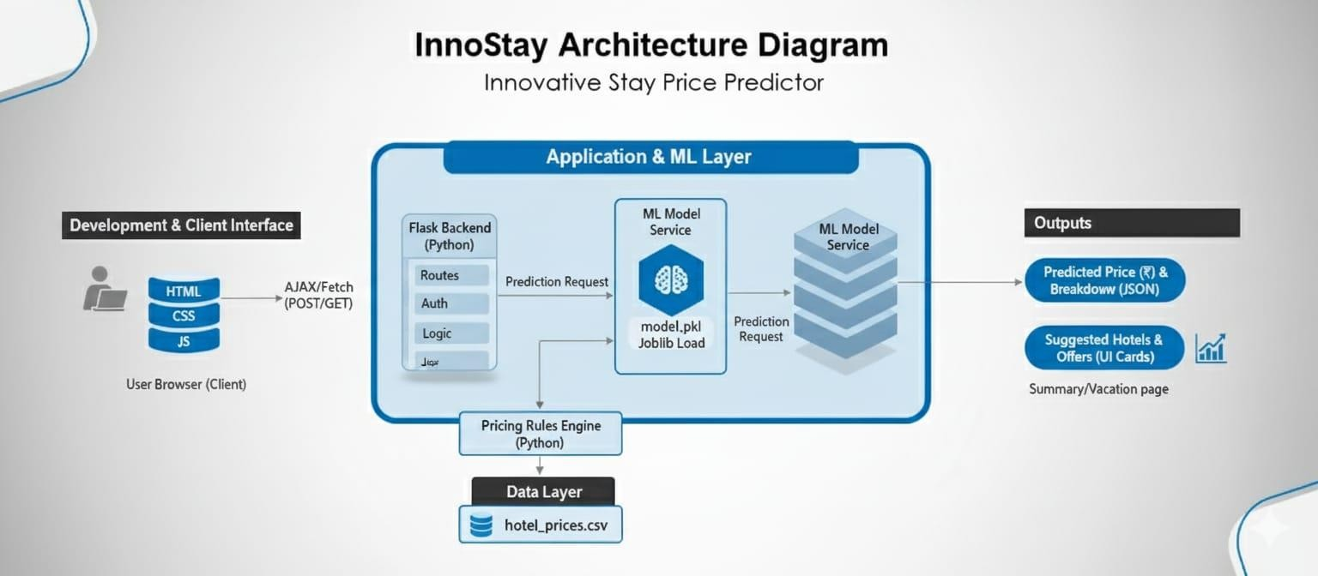

- MODULES DESCRIPTION
The system consists of two major modules that together manage user interaction, data processing, and prediction:
  - MODULE 1 – FRONTEND INTERFACE
This module focuses on the user interface and experience. The frontend is designed using HTML, CSS, and JavaScript with a light blue and white color theme. It features rounded cards, grid layouts, and icon-based visual elements for easy navigation. The four pages—Login, User Details, Price Prediction, and Summary/Vacation—allow the user to progress smoothly through the workflow.
The Prediction page enables users to input all necessary details including city, star rating, check-in month, guests, room type, and amenities. When the user clicks the “Predict Price” button, the data is sent asynchronously to the backend, and the predicted price is displayed dynamically using JavaScript DOM updates. The page also renders hotel cards with relevant images and icons such as Wi-Fi, Breakfast, Pool, and Spa, improving both functionality and aesthetics.

  - MODULE 2 – BACKEND AND MACHINE LEARNING MODEL
The backend is developed using Flask (Python), which handles all routes including /login, /user_details, /predict, and /history. It loads the trained model (model.pkl) and applies logic for real-time prediction. The backend also implements dynamic pricing rules such as summer surges (+20%), rainy discounts (−15%), and festive boosts (+25%), along with weekend or weekday adjustments.
When a request is received from the frontend, the backend processes the data, passes it through the ML model, applies business rules, and returns a JSON response. The backend also stores user history, allowing users to view previous predictions and compare prices.

- IMPLEMENTATION AND RESULTS
  - EXPERIMENTAL SETUP
Frontend: HTML, CSS, JavaScript
Backend: Flask (Python)
Libraries: Pandas, NumPy, Scikit-learn, XGBoost, Flask
Dataset: Kaggle Hotel Price Dataset (3,000+ records)
The web app was implemented and tested on Windows 10 and 11 using Visual
Studio Code as the development environment. The trained
RandomForestRegressor model achieved high accuracy, with an R² score of 0.91 and RMSE of 320. The system demonstrated stable performance and fast response times during prediction requests.

  - RESULTS
The system successfully predicts hotel prices based on user preferences and provides an interactive display of results. The output includes a predicted price in ₹, a cost breakdown modal showing the effects of amenities and seasonal adjustments, and suggested hotels that match the filters. The Summary page visualizes past predictions through a bar chart comparing predicted versus market prices, while the Vacation page displays promotional offers with icons for different seasons.

- CONCLUSION AND FUTURE WORK

The InnoStay – Innovative Stay Price Predictor project successfully demonstrates how AI and web technologies can be combined to solve practical problems in the hospitality domain. The system offers accurate hotel price predictions, personalized insights, and a smooth user experience.
Future improvements may include integrating live APIs for real-time hotel data, adding recommendation systems for suggesting hotels, and implementing advanced deep learning models to enhance prediction accuracy. The platform can also be extended to mobile apps, allowing users to check hotel price predictions anywhere.

- REFERENCES
[1]. Flask Documentation (2024). The Flask Framework – Official Guide. Retrieved from https://flask.palletsprojects.com
[2]. Kaggle Dataset (2024). Hotel Room Price Prediction Dataset. Retrieved from https://www.kaggle.com
[3]. Scikit-learn (2024). Machine Learning in Python – Documentation. Retrieved from https://scikit-learn.org
[4]. XGBoost Documentation (2024). Gradient Boosted Decision Trees. Retrieved from https://xgboost.readthedocs.io

